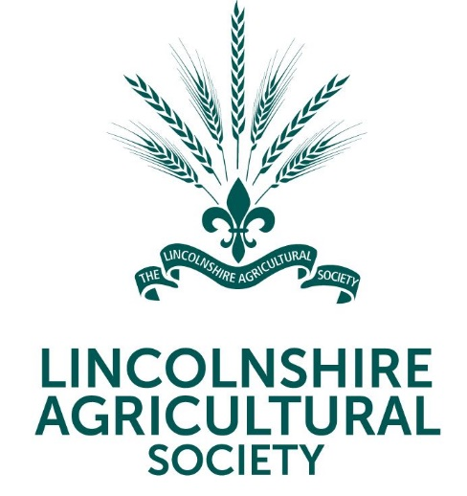 | 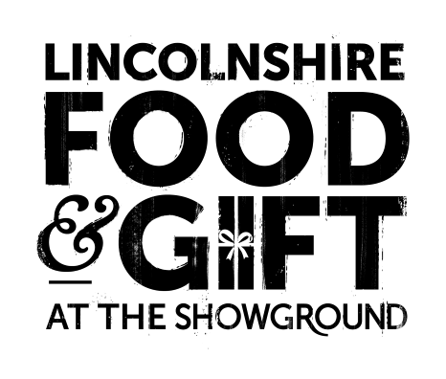
News Release

19th October 2023

Enjoy Storytime with Santa at the Lincolnshire Food & Gift Fair

A very special guest will be spreading some early Christmas cheer at this year’s Food & Gift Fair at the Lincolnshire Showground.

Santa Claus will be meeting children at the two-day event on Saturday 25th and Sunday 26th November.

As well as receiving a small gift, children will be able to enjoy a glass of milk and a cookie while listening to Santa read a Christmas-themed story. There’ll also be the chance to have a photo taken with the big man himself.

Lincolnshire Agricultural Society Chief Executive Charlotte Powell said: “Storytime with Santa is a lovely new experience for this year and we’re very grateful to our sponsors Gadsby’s Bakery, Flames of Lincoln, Flowers by Suzanne and Blue Diamond for helping us to make this happen.

“We anticipate the chance to meet Santa will be extremely popular and places are limited so I would advise anyone interested to go online and book their tickets as soon as possible!

“Of course, if you don’t manage to book a place there’s still lots more for our younger visitors to do, including making Christmas tree decorations and tree-shaped pizzas in Santa’s Workshop and Bakehouse.

“We really do have a Christmas cracker of an event lined up this year so please come along and join in the fun. It’s the perfect way to get into the festive spirit!”

Adults will also have the opportunity to get creative with the floristry team from the Lincolnshire Co-op who will be teaching people how to make door swags, table arrangements and wreaths.

All materials are provided, and participants will receive a free mince pie and a drink. Once again spaces are limited so booking in advance via the website is strongly advised.

And all of this will be taking place against a backdrop of hundreds of stalls selling everything from jewellery to jam and live performances by local musicians including the Lincolnshire Fire & Rescue Band and Nettleham Community Choir.

Tickets for the Lincolnshire Food & Gift Fair cost £5.50 (plus a booking fee) in advance from lincolnshireshowground.co.uk/food-gift or £7.00 on the door. Children under five and parking are free.

Tickets for Storytime with Santa cost £8 per child (plus a booking fee). All children must be accompanied by an adult. One adult is free, and tickets for additional adults cost £3 each (plus a booking fee). Adult workshop prices start from £40.50 (plus booking fee).

For more information, please visit lincolnshireshowground.co.uk/food-gift

Ends

Note to Editors

- The 270-acre Lincolnshire Showground is owned by the Lincolnshire Agricultural Society (LAS) which was formed in 1869 and celebrated its 150 anniversary in 2019.
- As a charitable organisation its objectives are to educate the county about food, farming and a sustainable environment. 100% of surplus funds from events are gift aided back into the charity to deliver the charity’s educational work.
- For more information, please visit lincolnshireshowground.co.uk

For media enquiries please contact:
Kate Strawson
Director
Shooting Star
kate@weareshootingstar.co.uk
01522 528 540 / 07733 230 293

